Lab Report No 1:

MATLAB Training

FALL 2022

**Digital Signal Processing**



Submitted By: **Maaz Habib**

Registration No: **20PWCSE1952**

Section**: C**

“On my honor, as student of University of Engineering and Technology, I have neither given nor received unauthorized assistance on this academic work”

Submitted To:

**Engr. Ihsan Ul Haq**

Department of Computer Systems Engineering

University of Engineering and Technology Peshawar

* **Course Overview**

Objective: Familiarize yourself with the course.

* **Commands**

Objective: Enter commands in MATLAB to perform calculations and create

Variables.

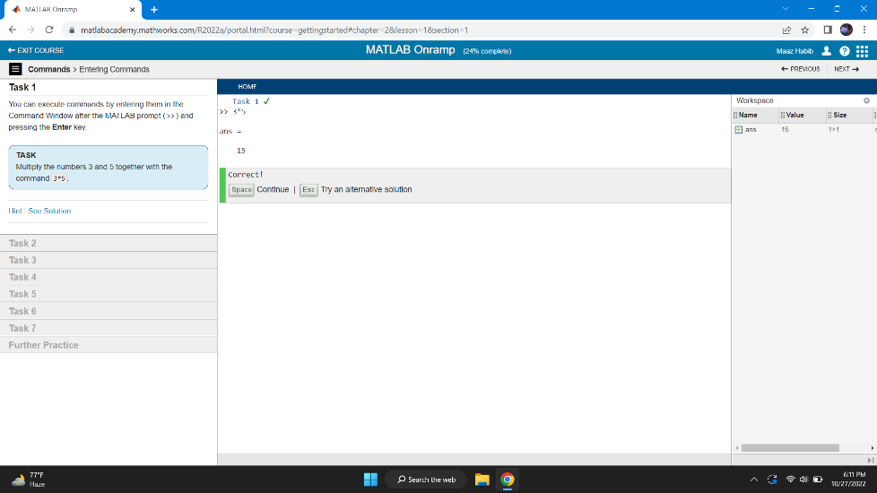 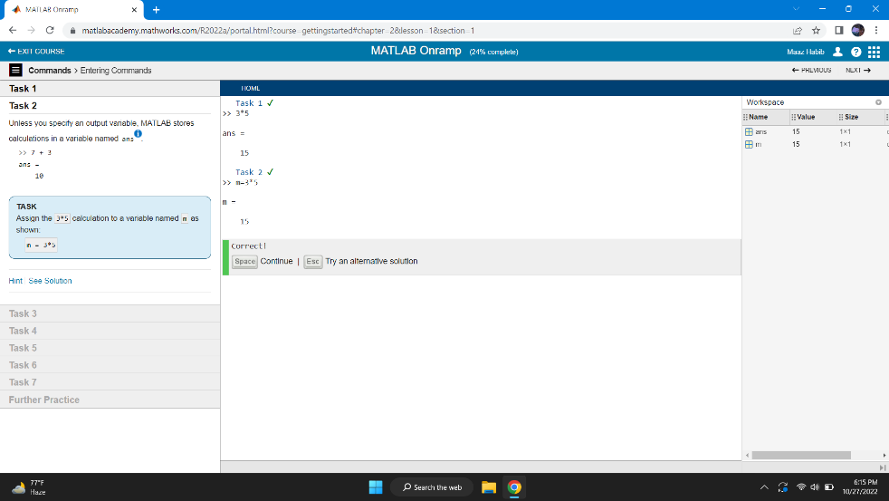

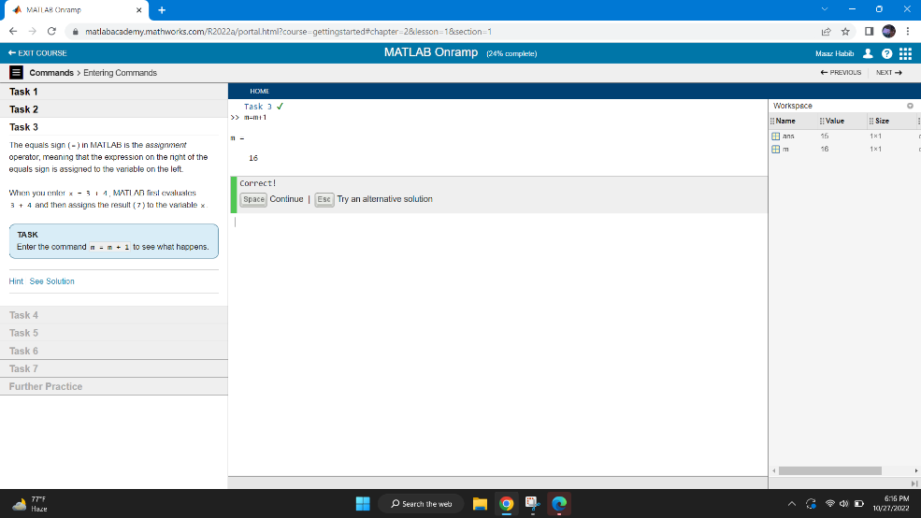

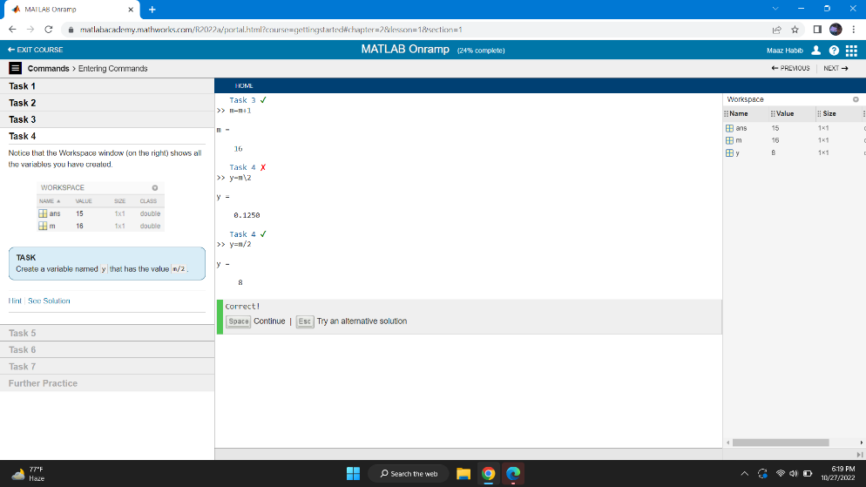

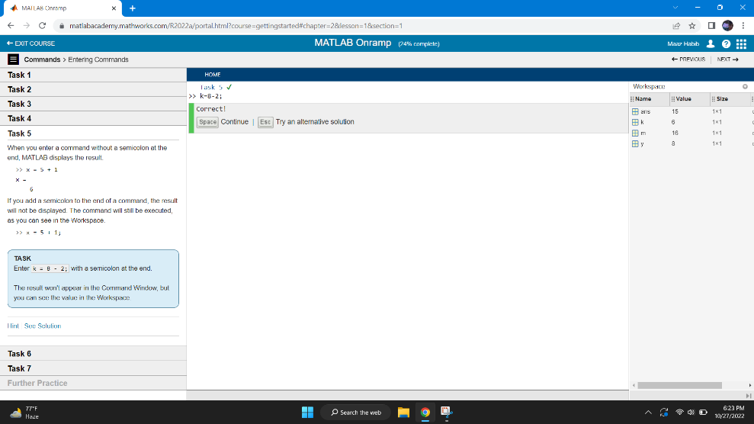

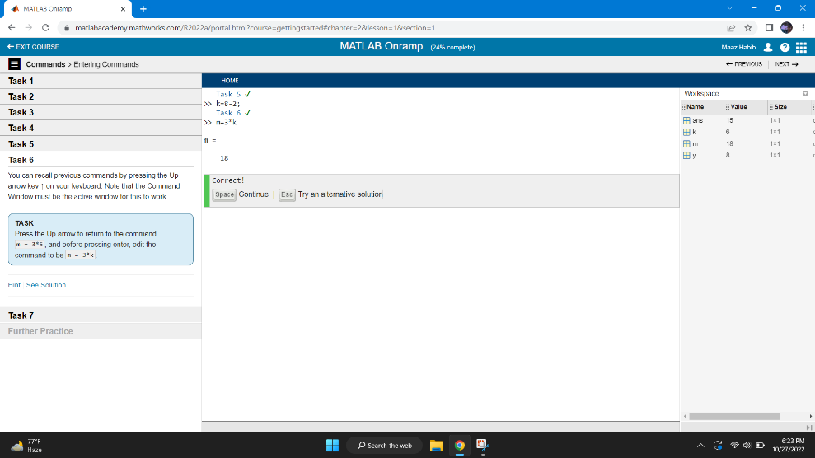

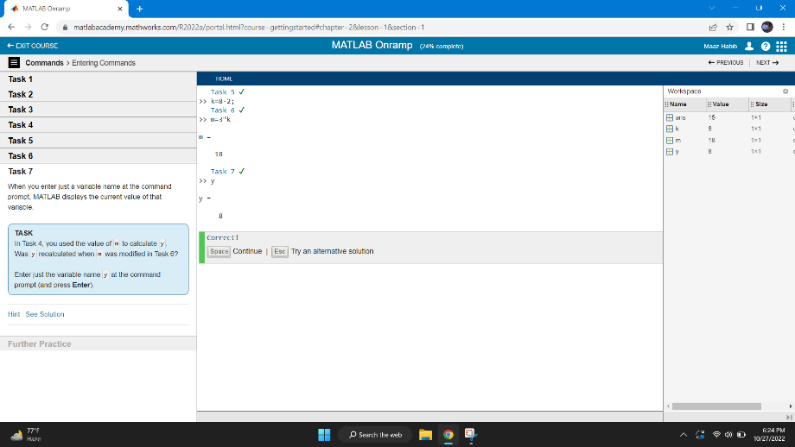

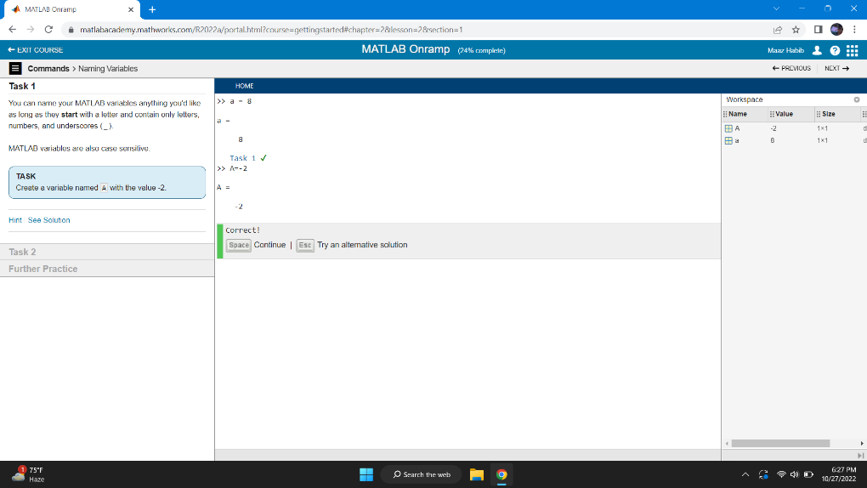

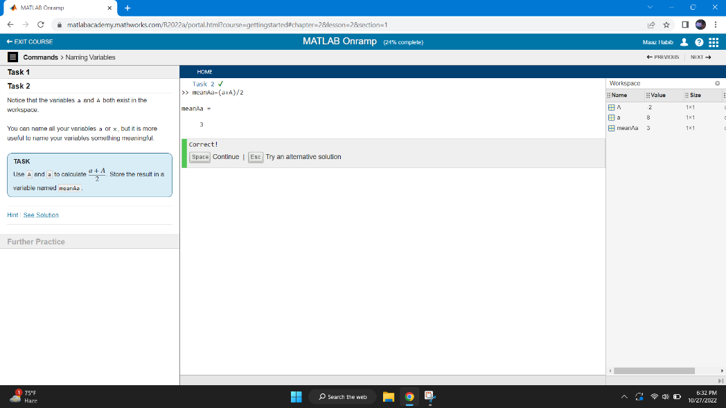

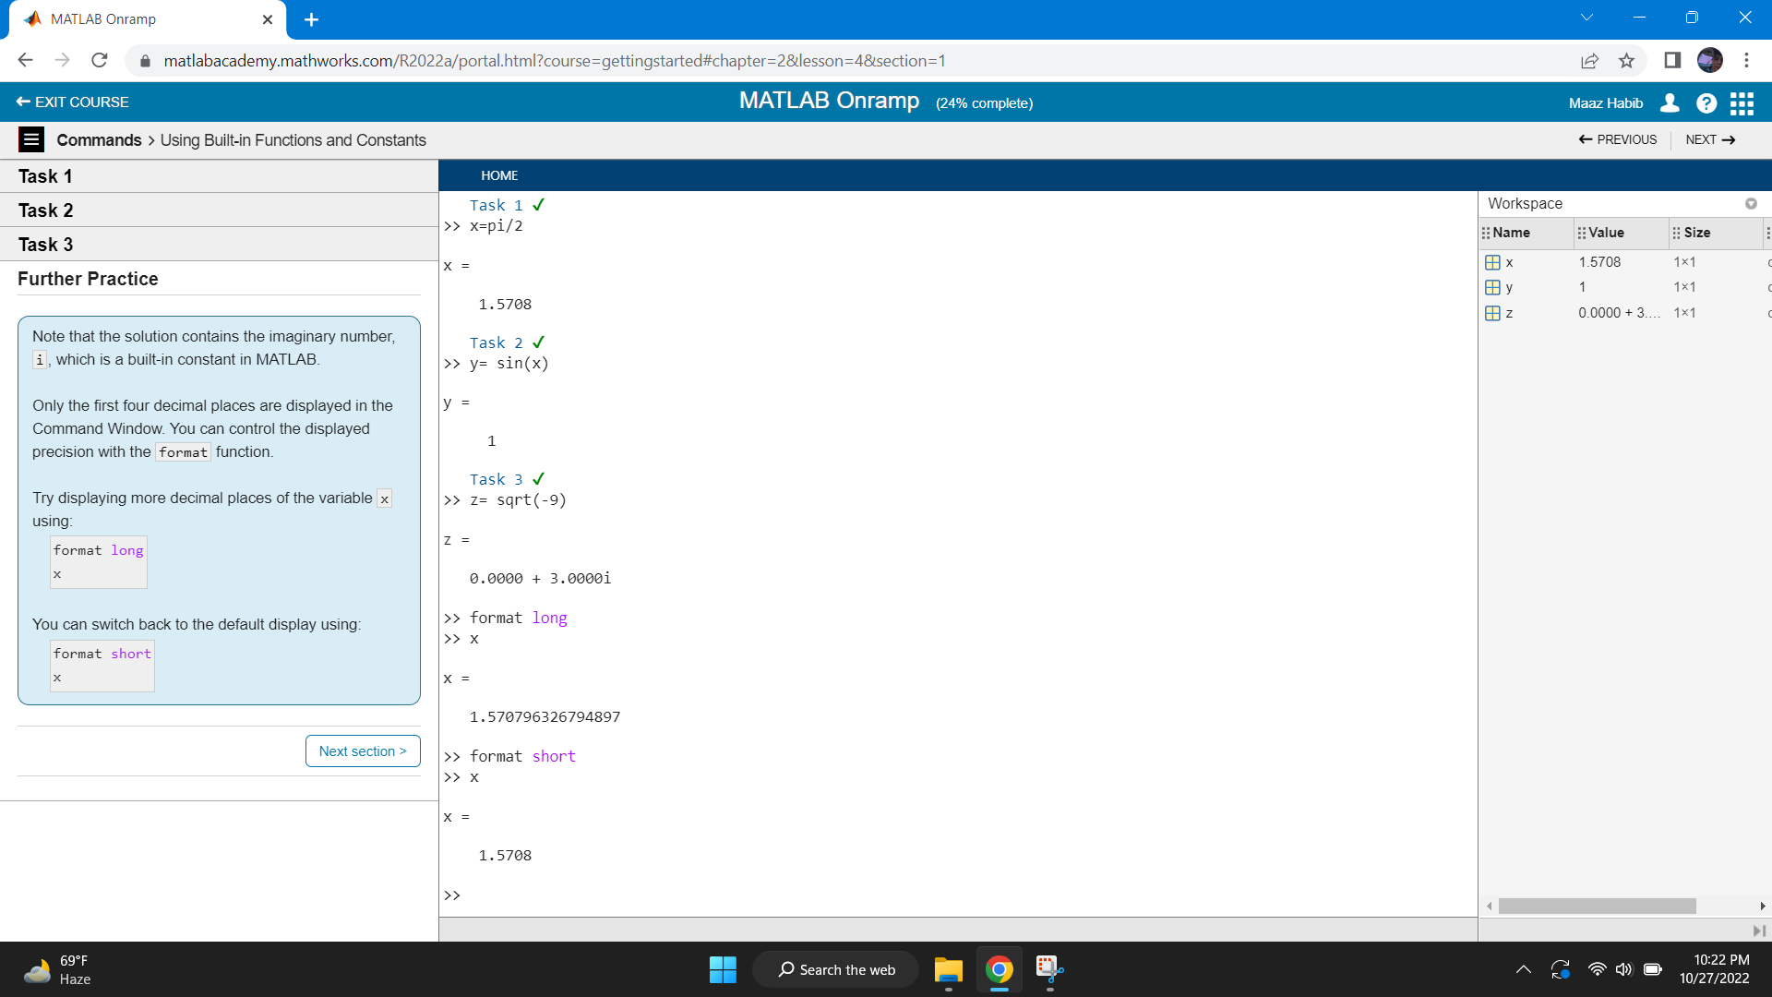

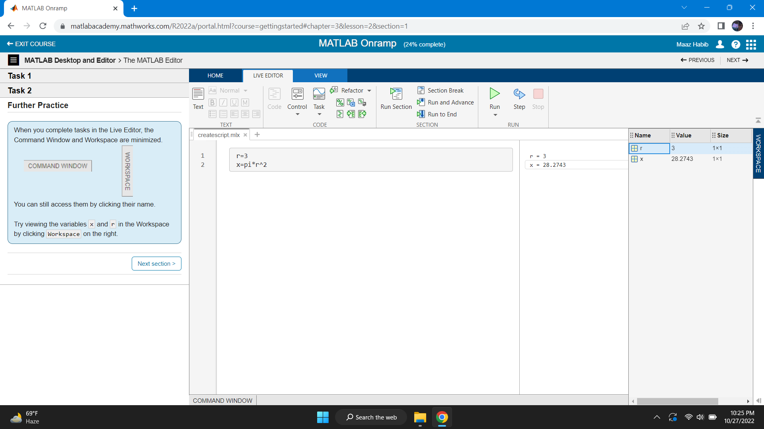

**3. Vectors and Matrices**

Objective: Create MATLAB variables that contain multiple elements.

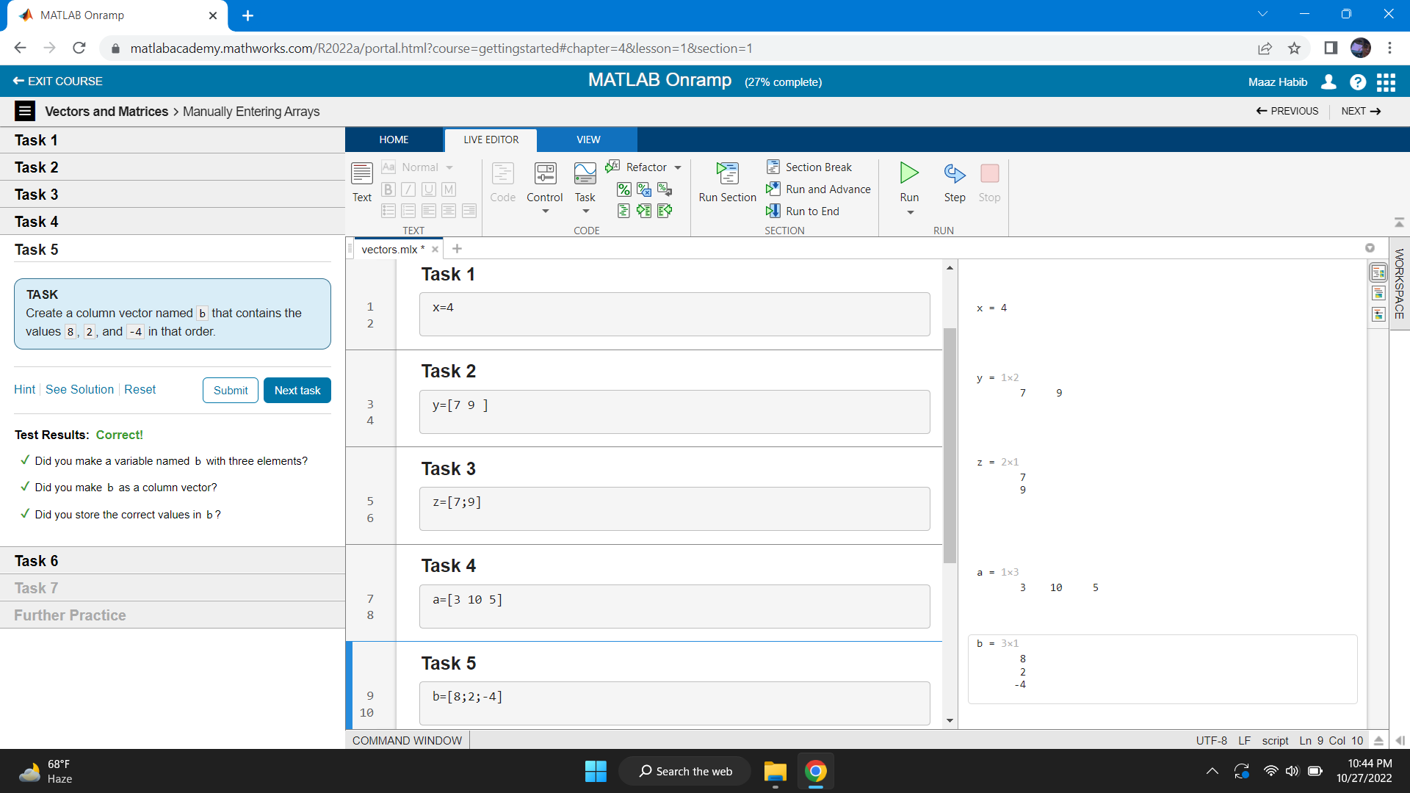

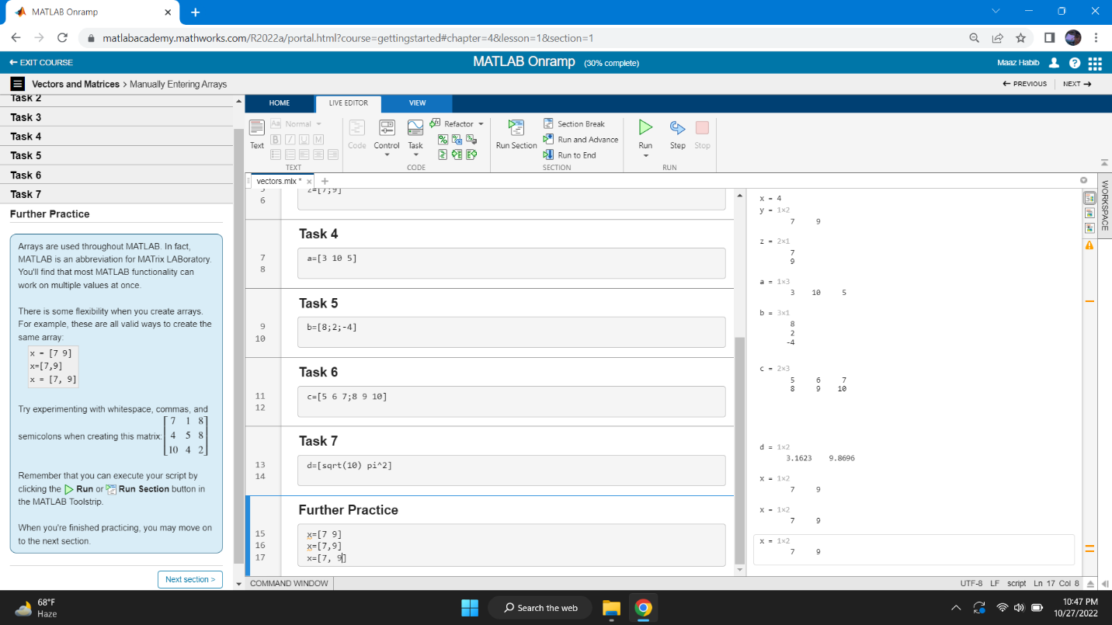

* **Importing Data**

Objective: Bring data from external files into MATLAB.

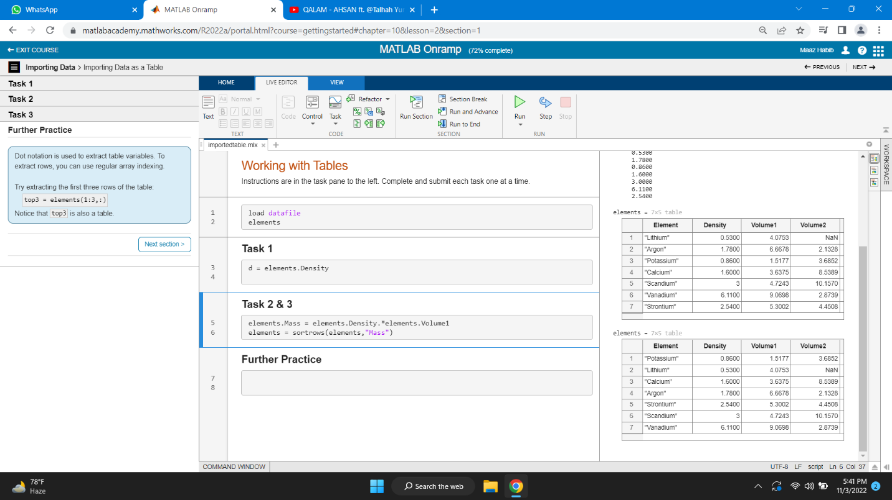

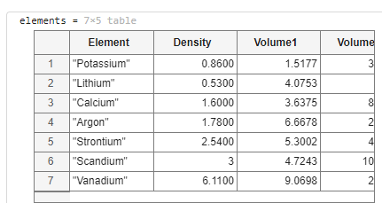

* **Indexing into and Modifying Arrays**

Use indexing to extract and modify rows, columns, and elements of MATLAB

Array.

* **Array Calculations**

Objective: Perform calculations on entire arrays at once.

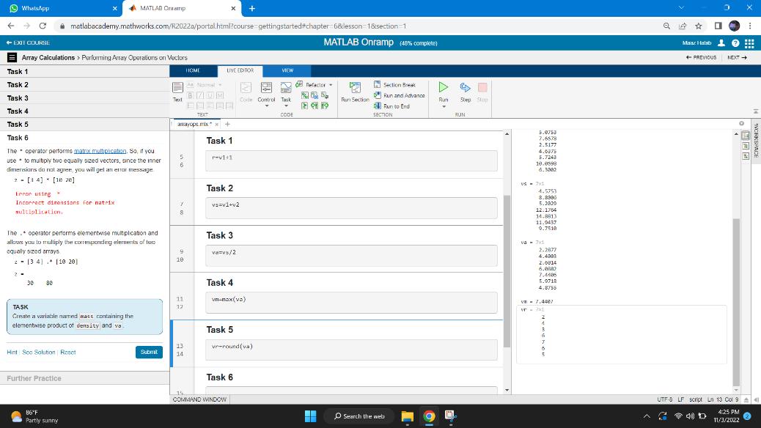

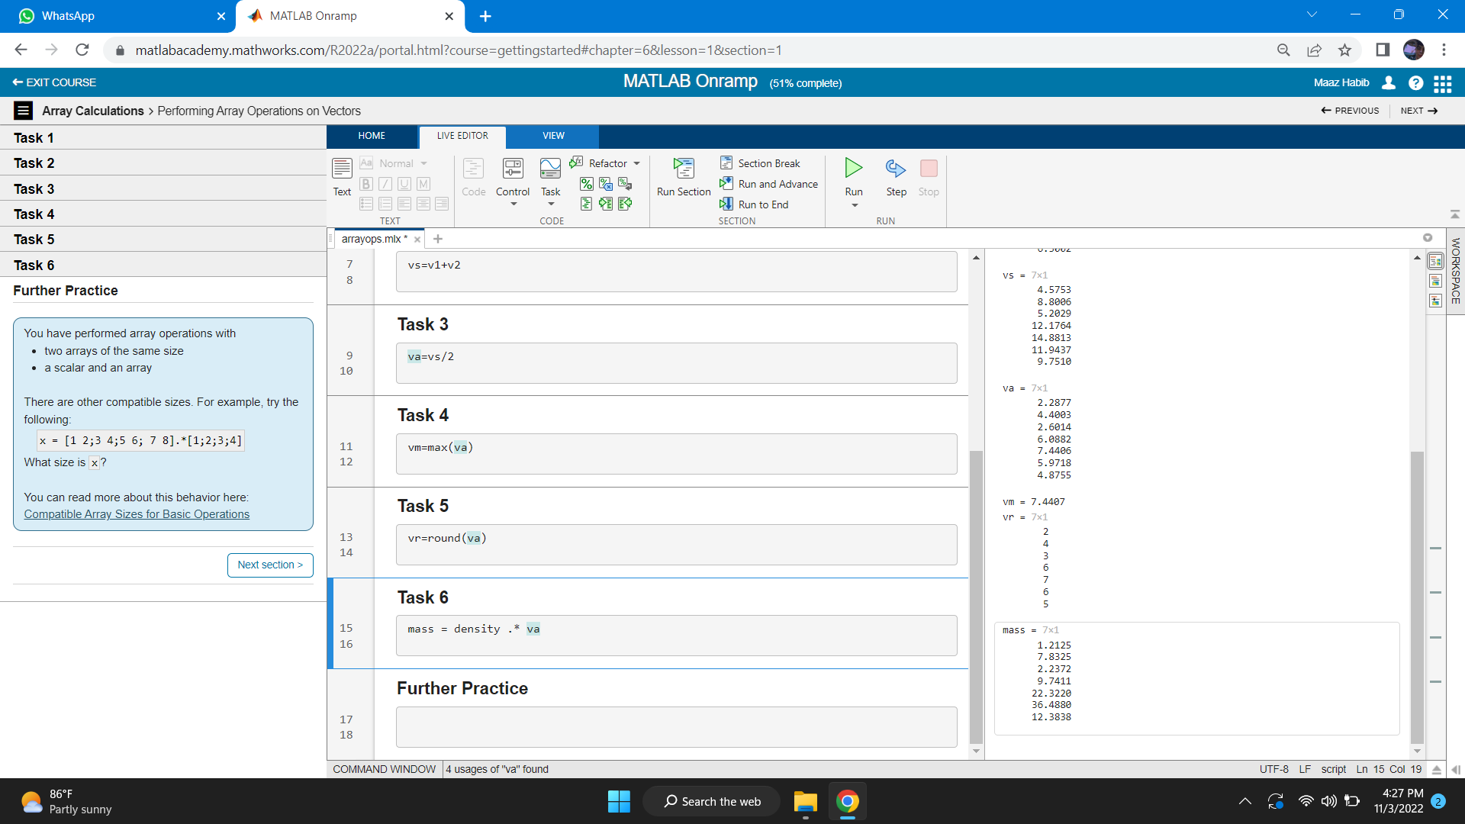

* **Indexing array**

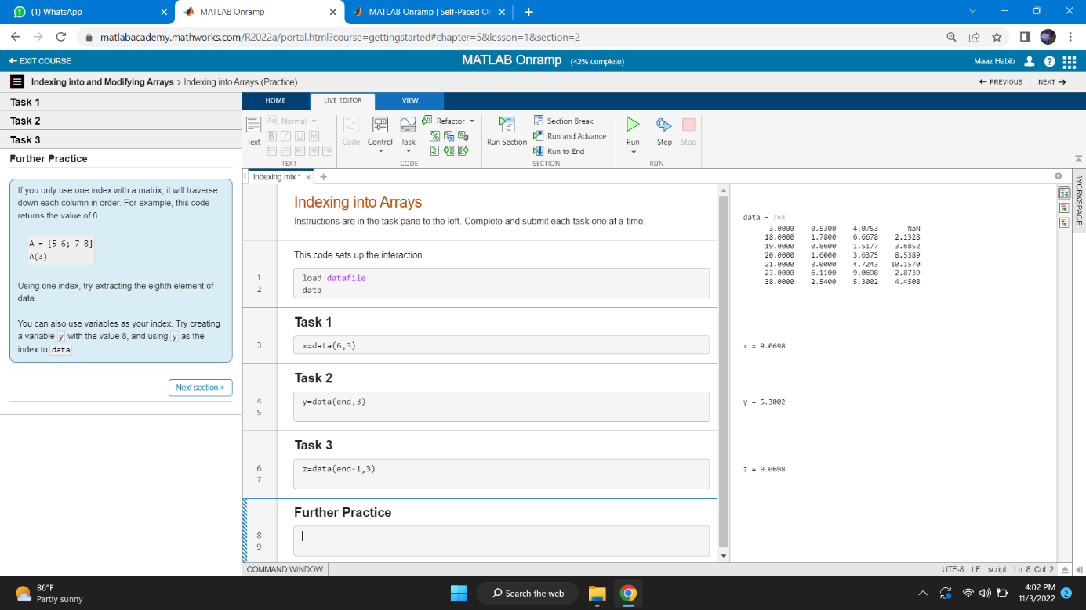

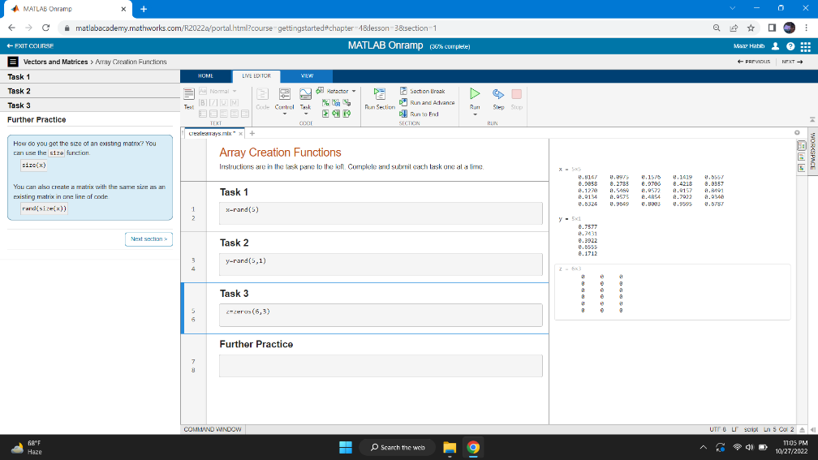

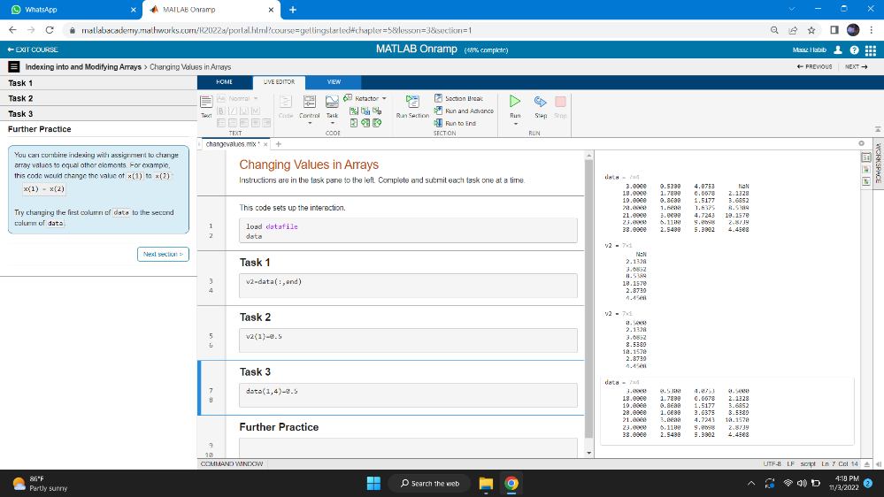

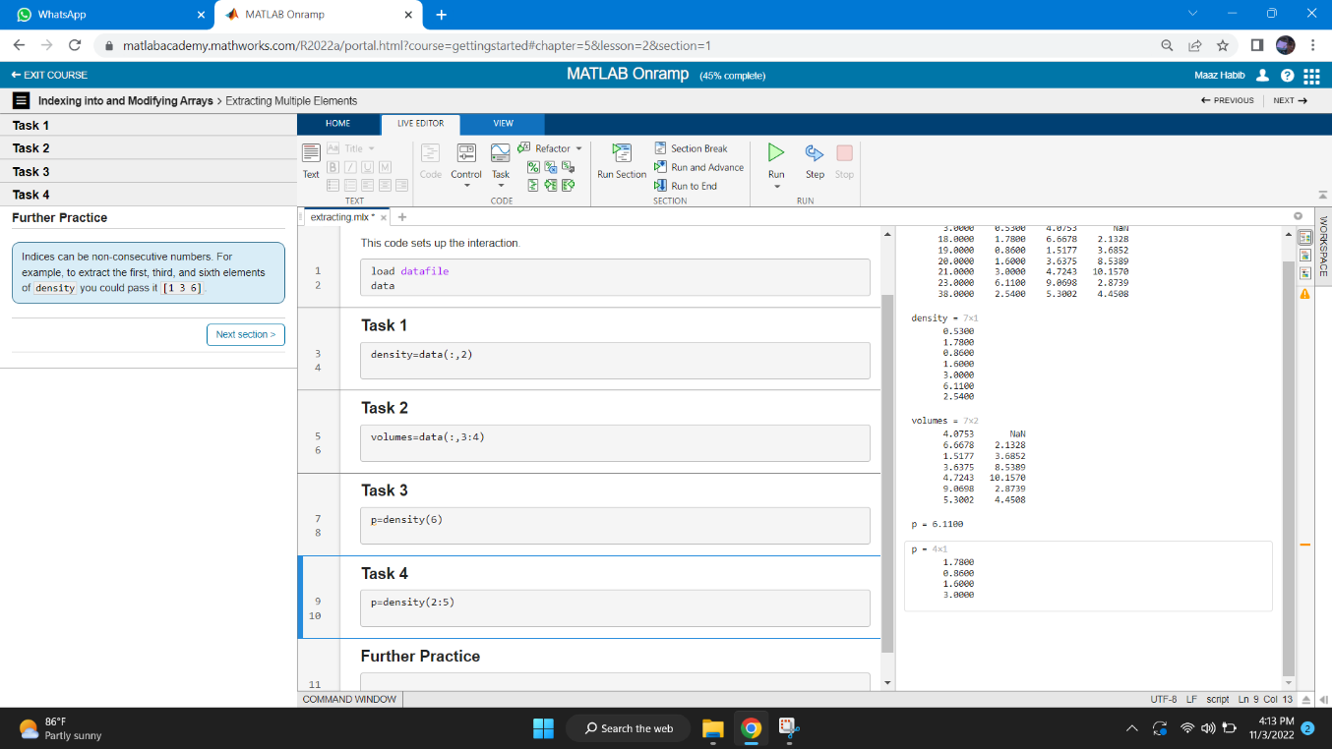

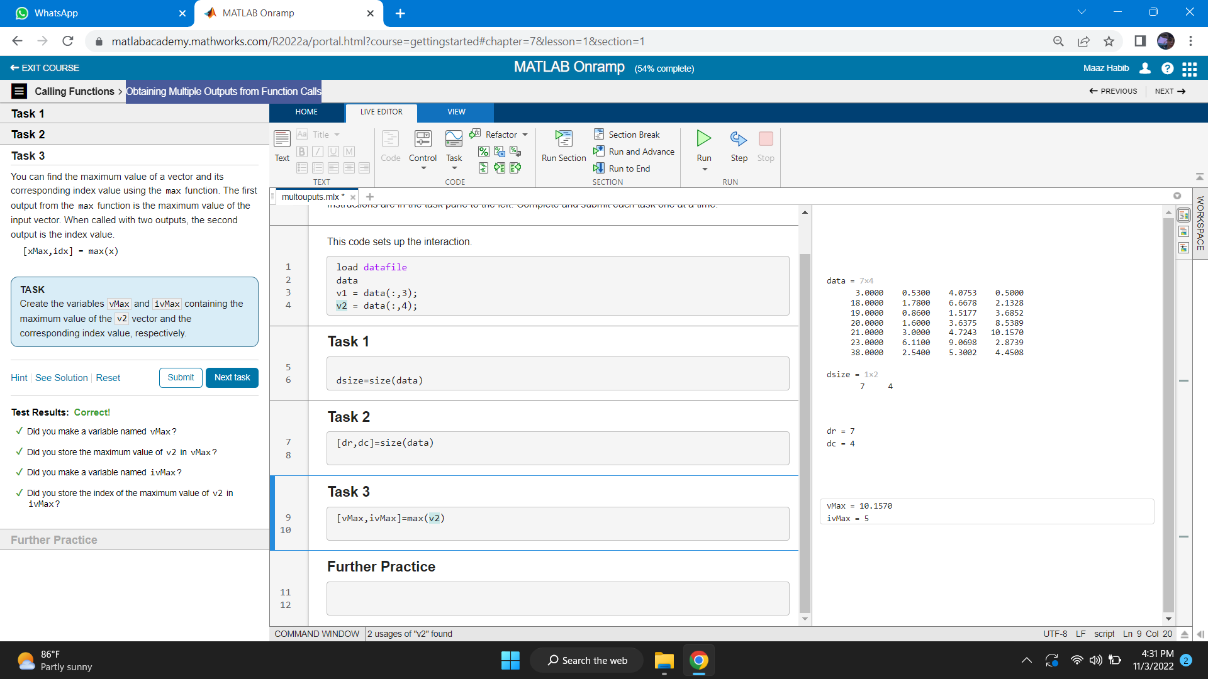

* **Calling Functions**

Objective: Call functions to obtain multiple outputs

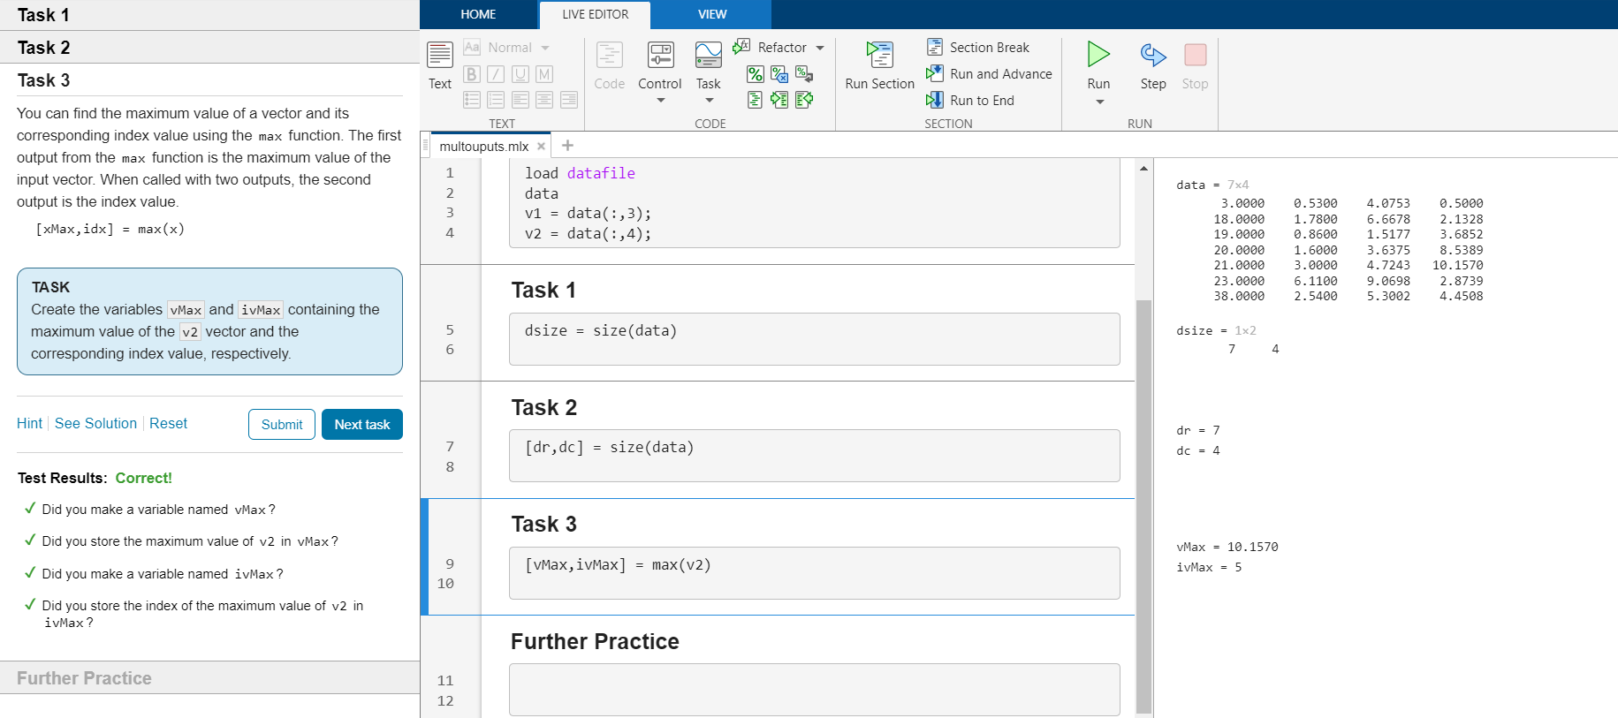

**Obtaining Help**

Objective: Use the MATLAB documentation to discover information about

MATLAB features.

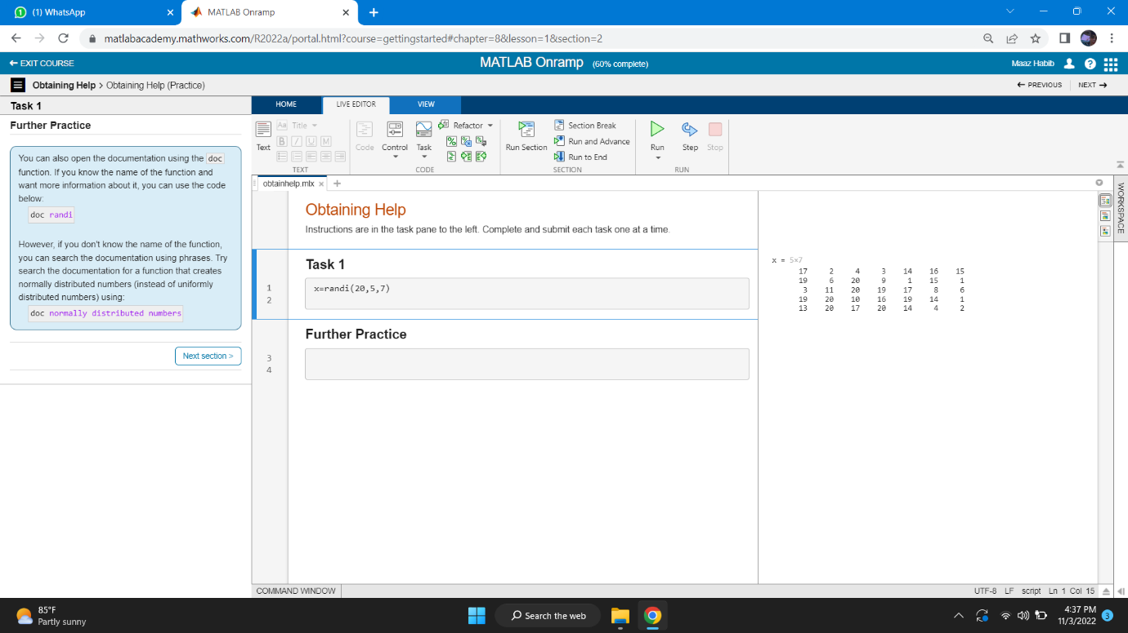

**Plotting Data**

Visualize variables using MATLAB&#39;s plotting functions.

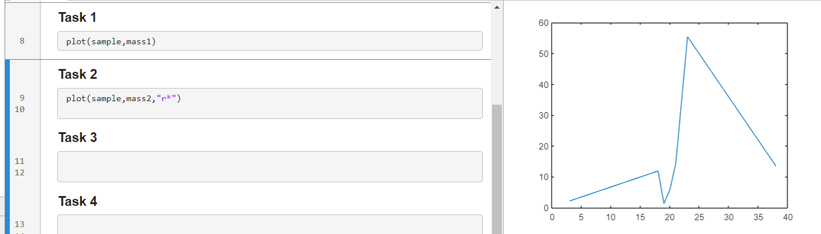

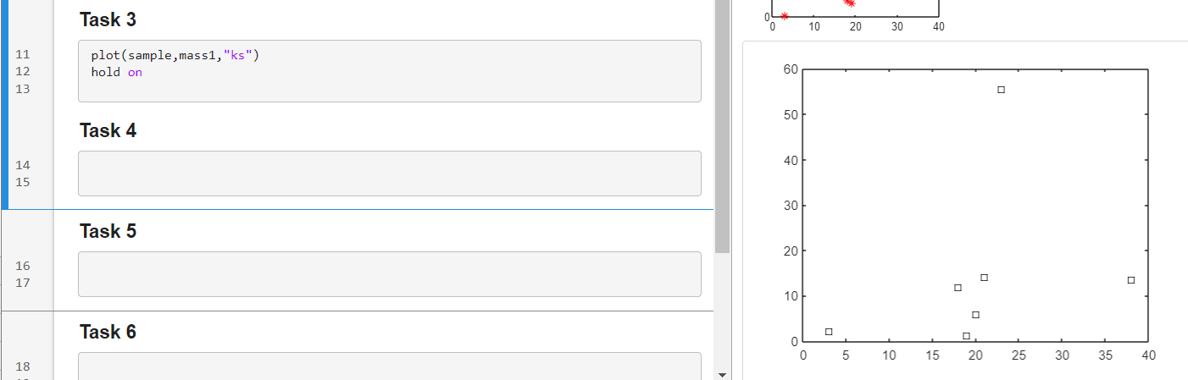

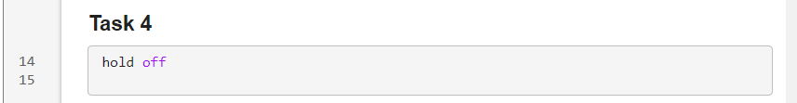

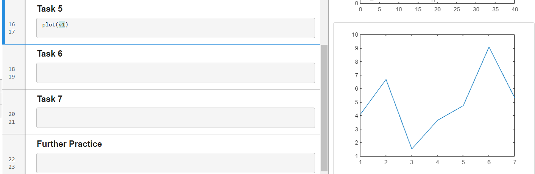

* **Review Problems**

Objective: Bring together concepts that you have learned with a project.

* **MATLAB Scripts**

Objective: Write and save your own MATLAB programs

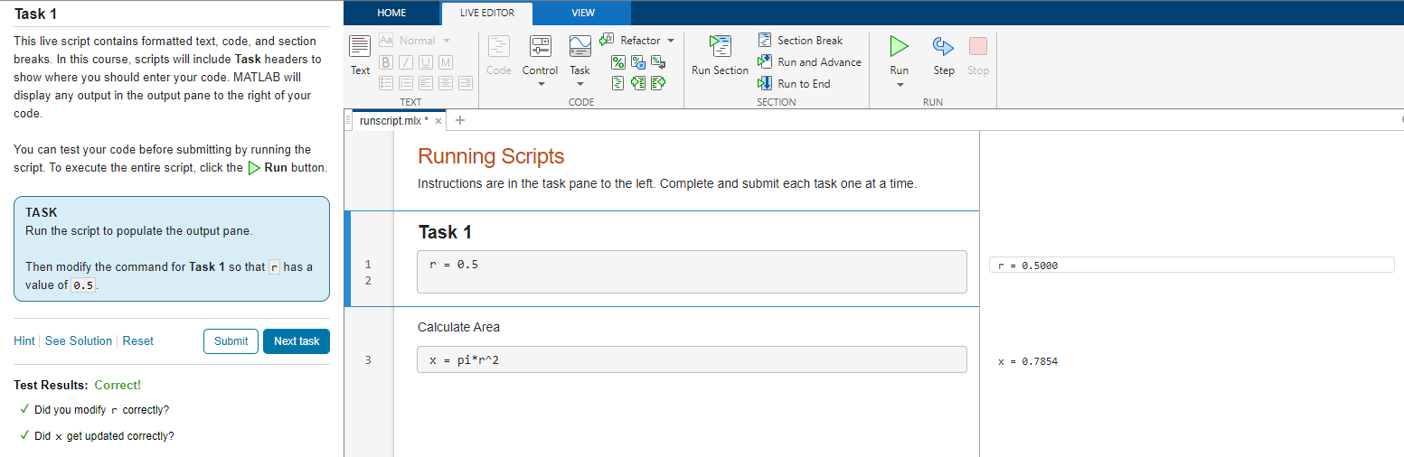

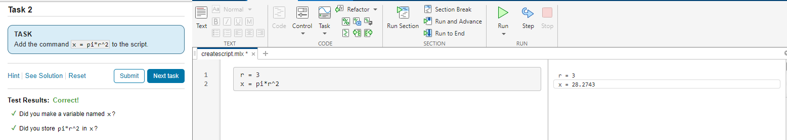



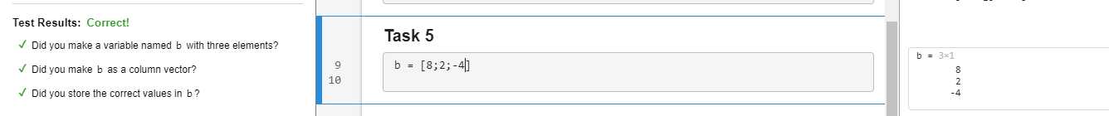



* **Logical Arrays**

Objective: Use logical expressions to help you to extract elements of interest

from MATLAB arrays.

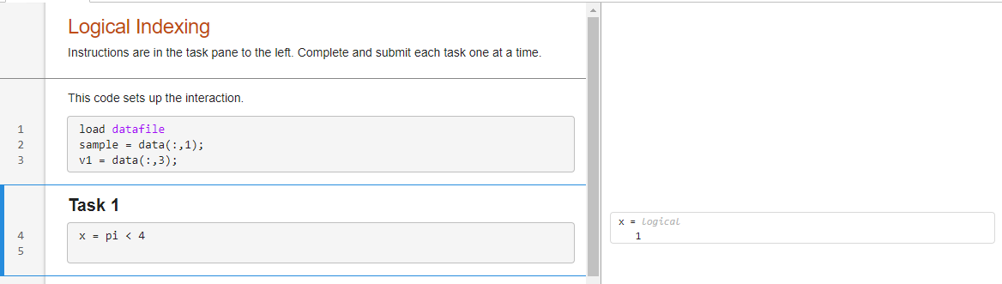

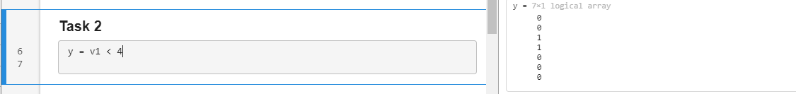



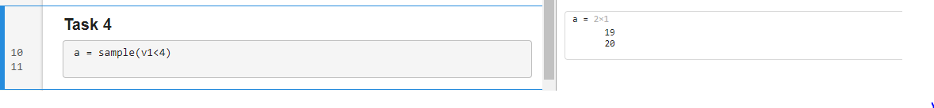

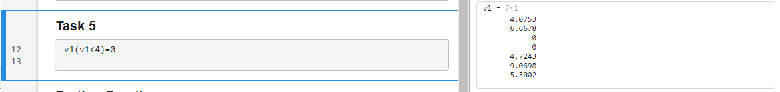

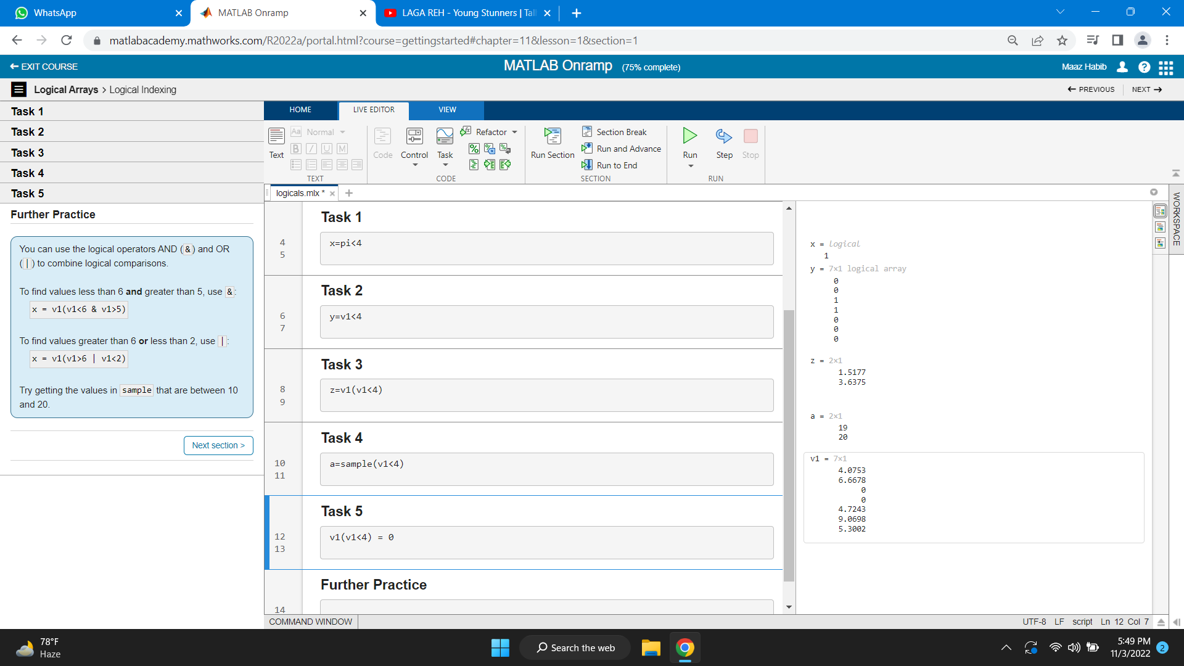

* **Programming**

Objective: Write programs that execute code based upon some condition.

**Final Project**

Objective: Bring together concepts that you have learned with a project.

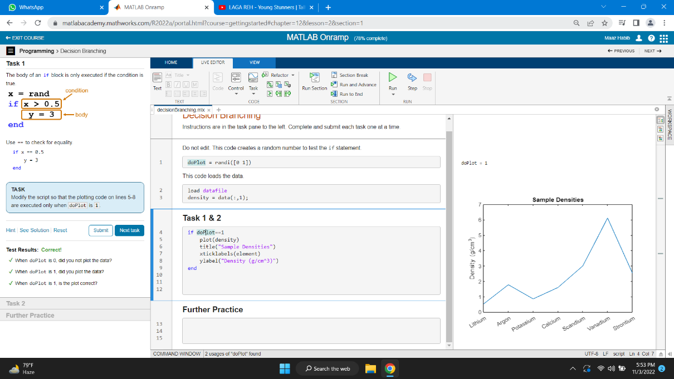

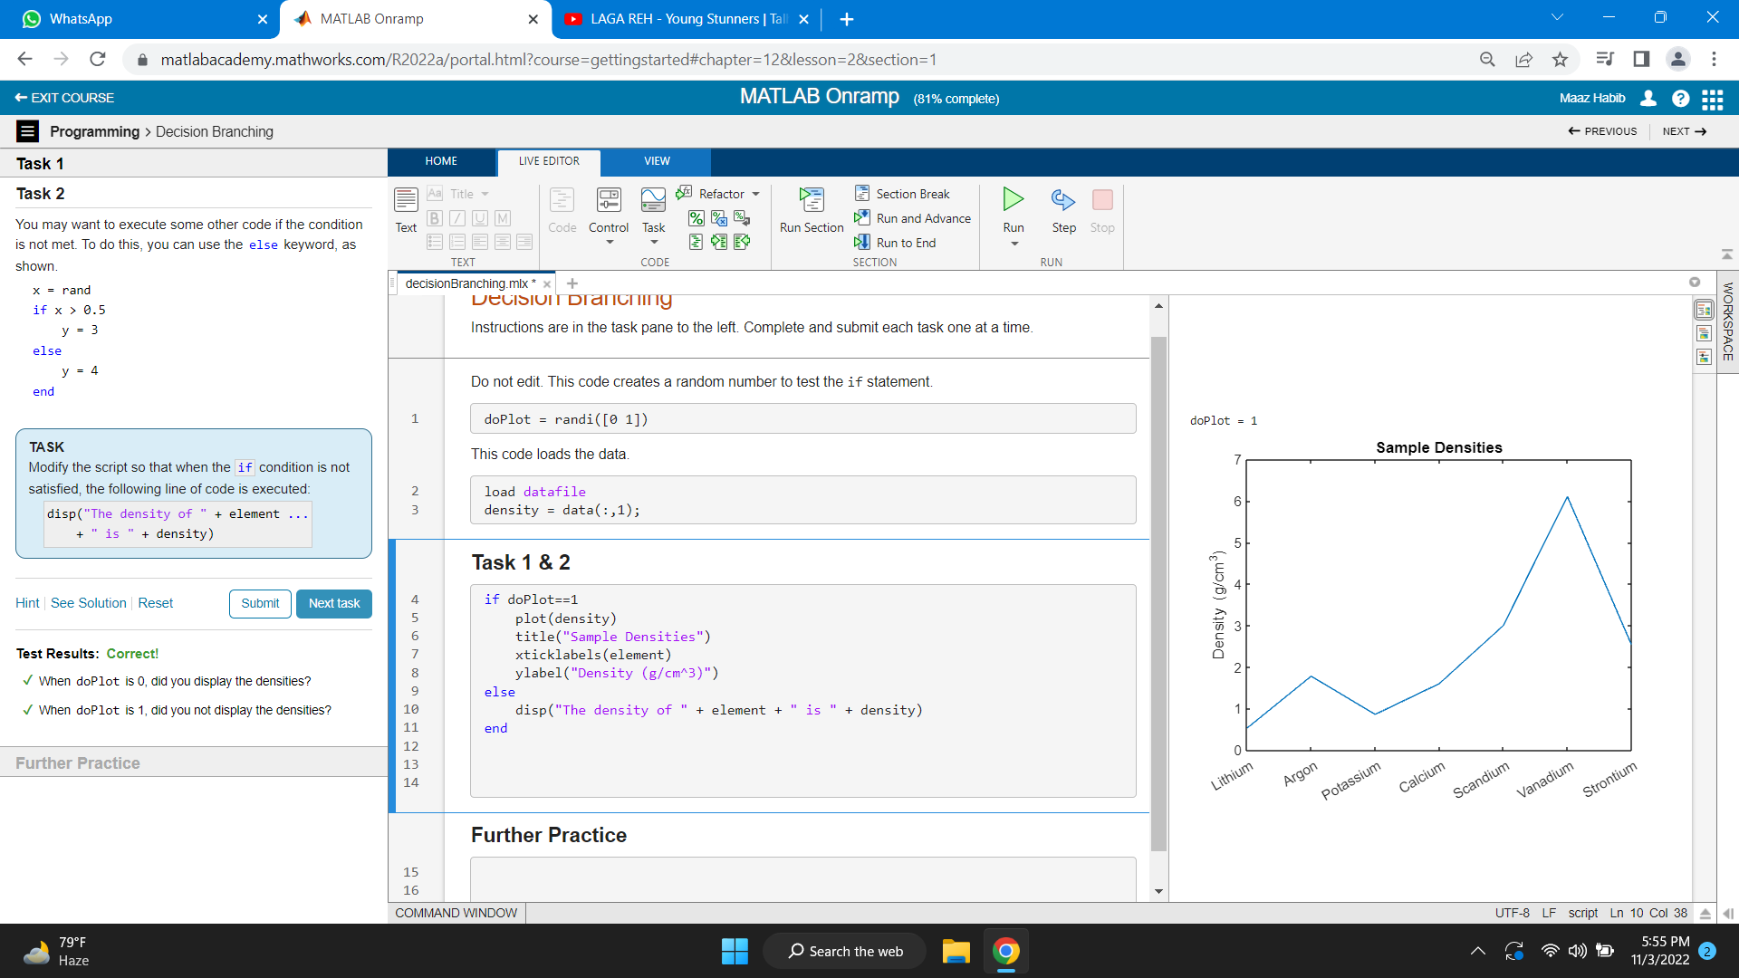

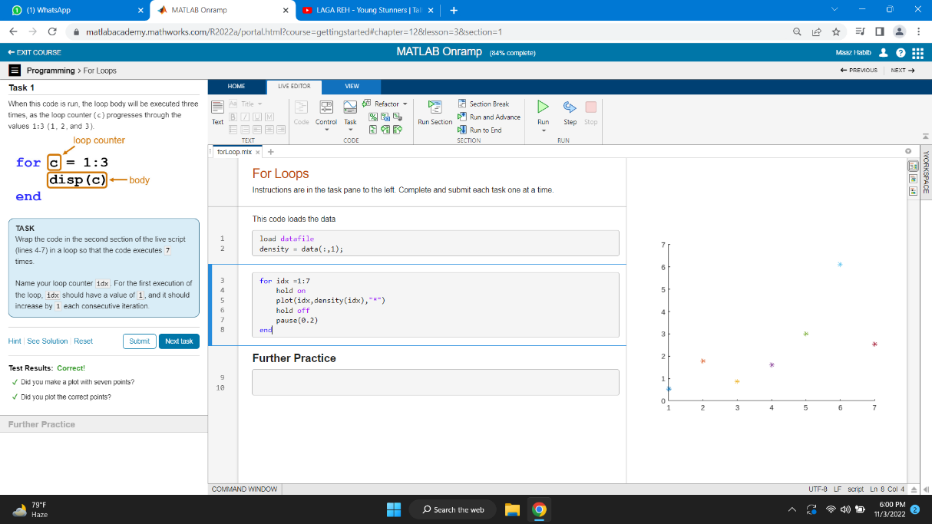

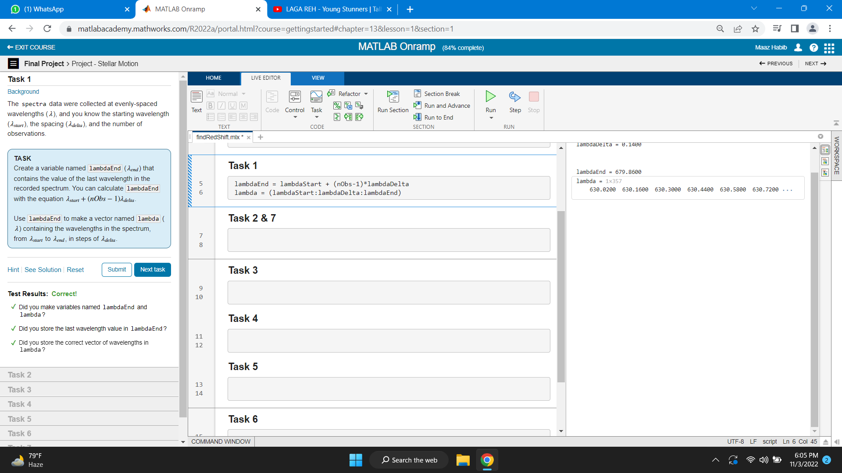

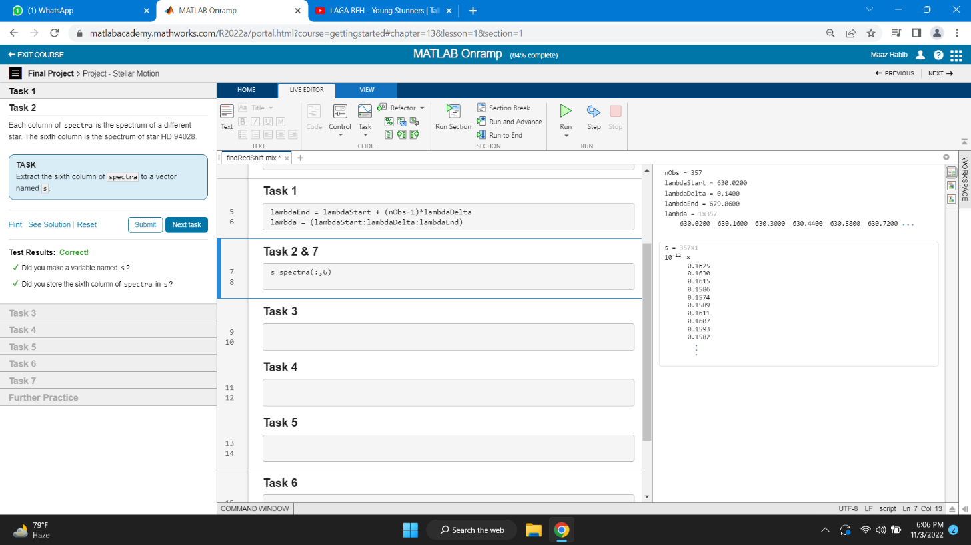

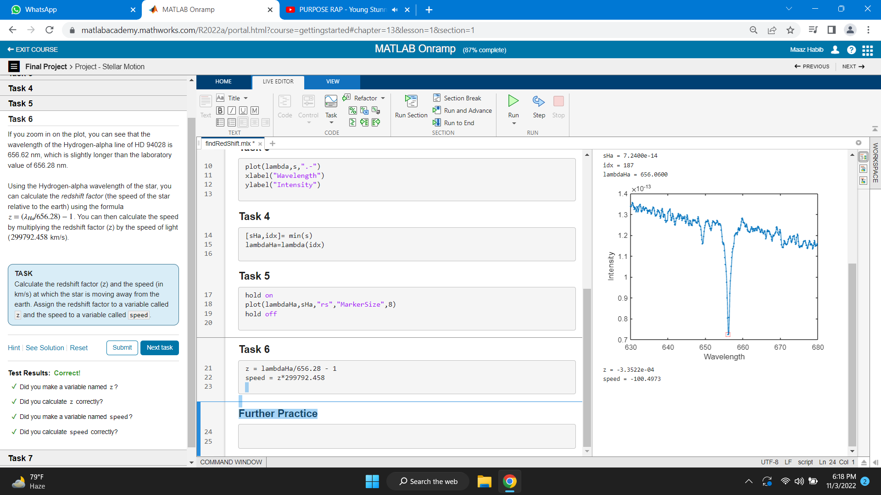

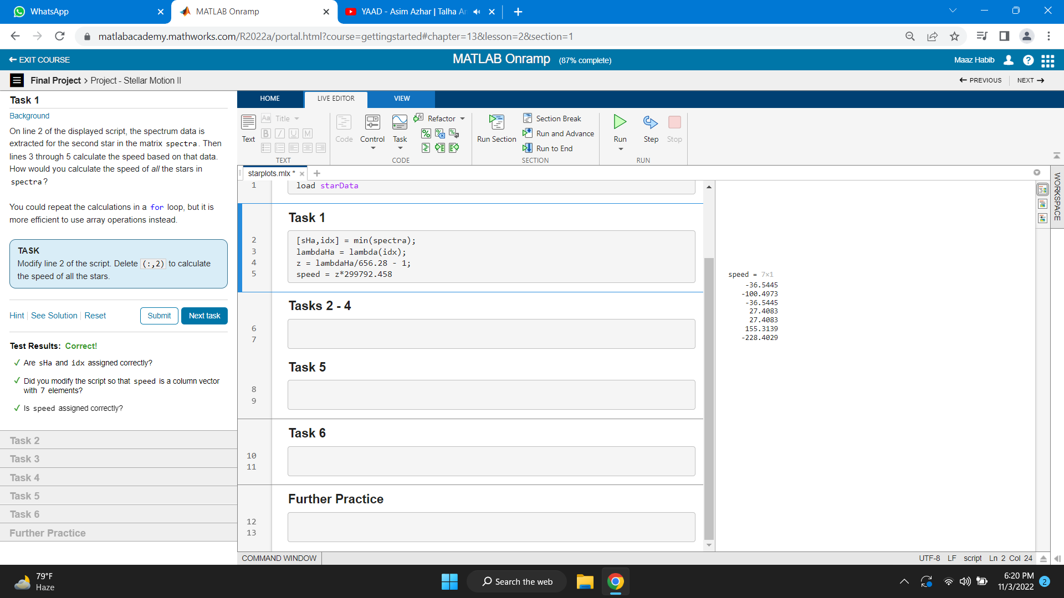

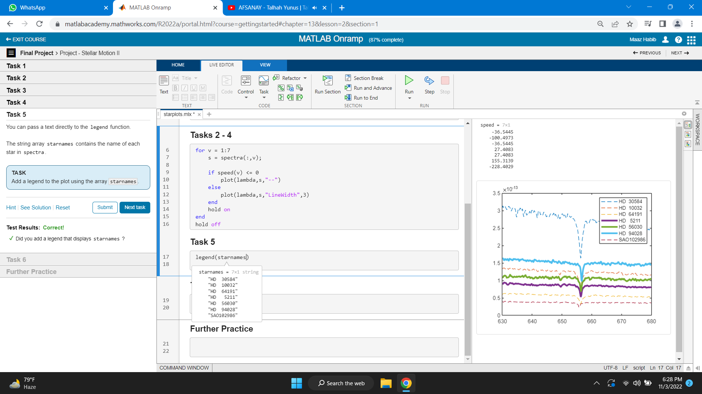

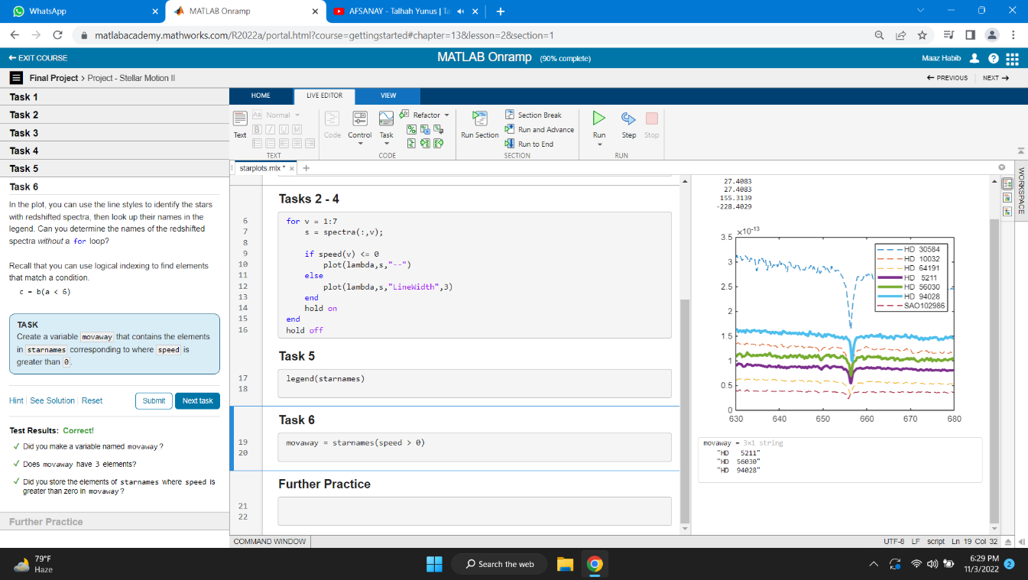

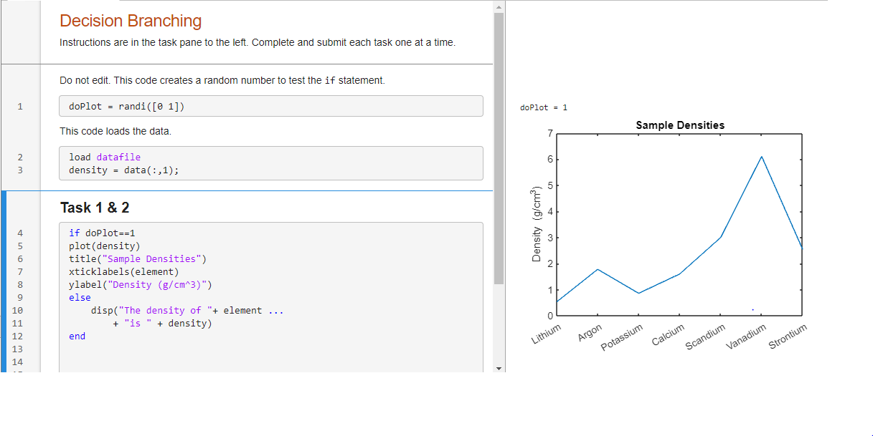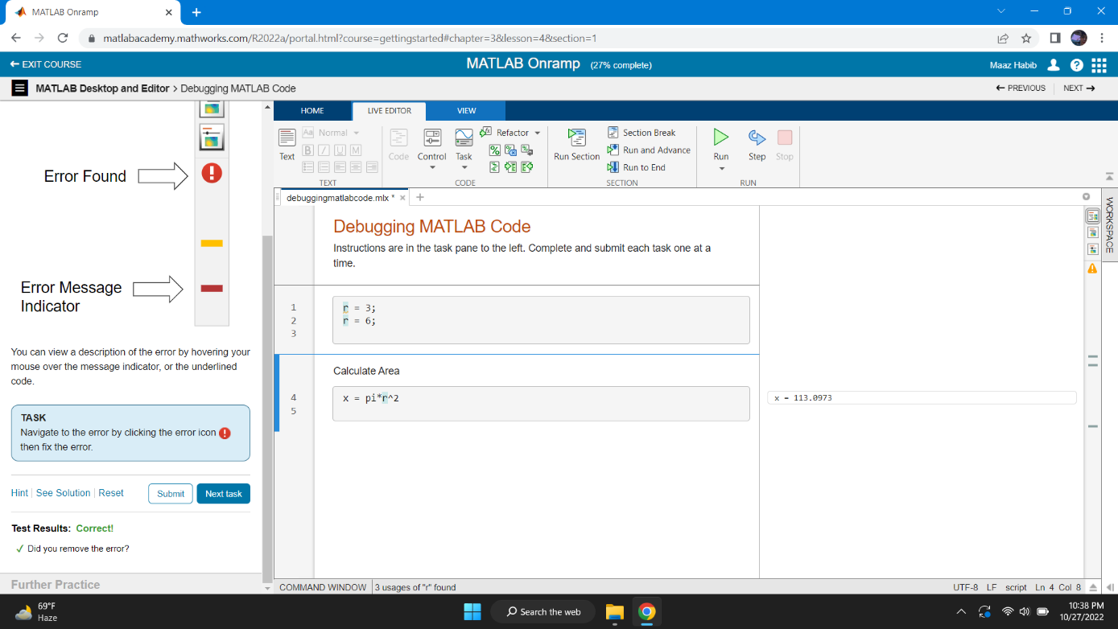

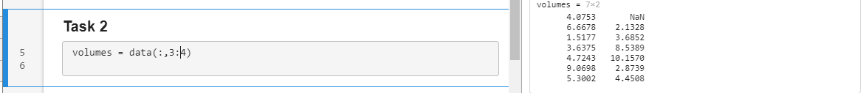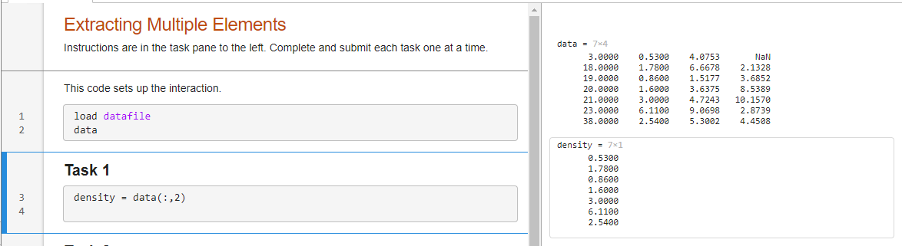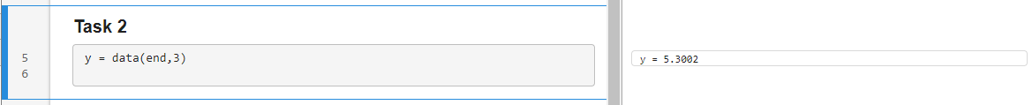

* Completiion of Course

